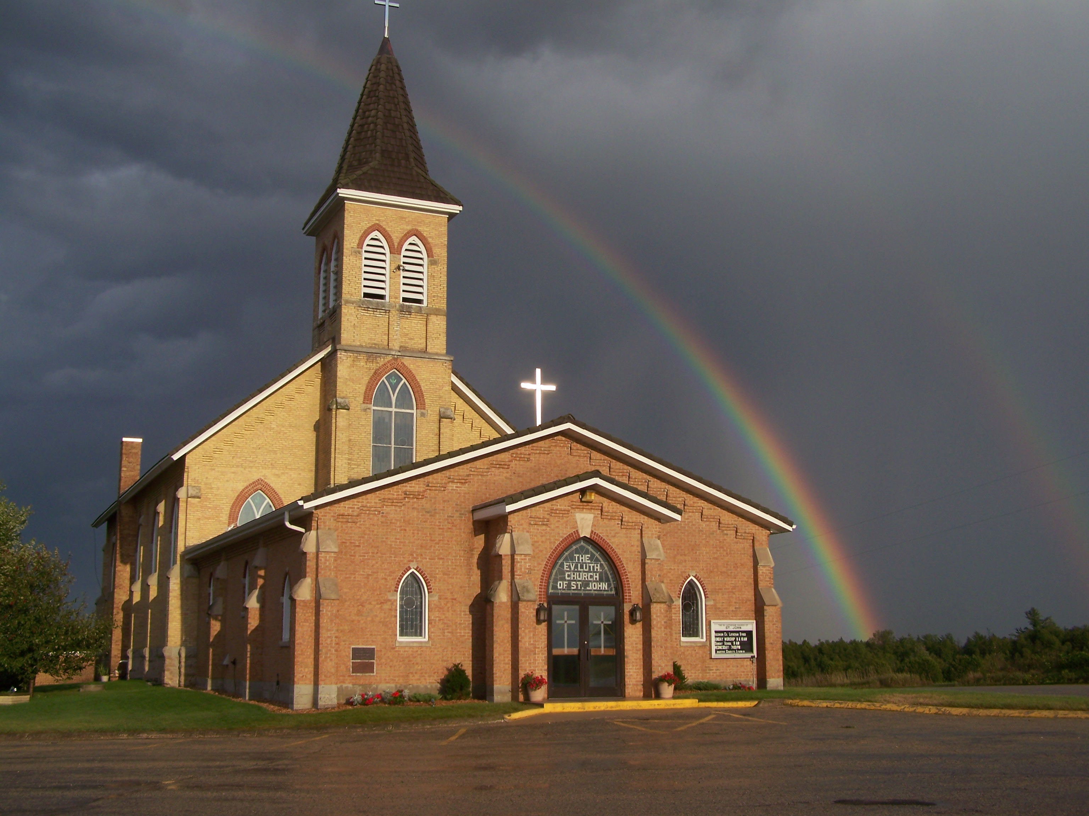
The Evangelical Lutheran Church of St. John
N1916 Church Road
Peshtigo, Wisconsin 54157-9673
Pastor Sargent 920-228-1061

08/20/2020
Dear members of St. John,
The weather looks threatening. A storm coming. The siren sounds. Take shelter immediately! The warning is serious. If you take your eye off the task at hand, get distracted, it can lead to disaster. What is that storm? It is doubt!
In our text for Sunday’s message (Matthew 14:22-33), Jesus had a powerful lesson to teach. It happened that night on the Sea of Galilee. He told his disciples they need to focus. He was teaching them about faith. Faith’s most basic definition is trust. Doubt is the enemy of faith! If our faith is attacked by doubt what can we do? “Focus!” Jesus says. “Keep your eyes on me!”

Worship
We will worship with no more than 100 people in attendance for each service. At this time, we will not need to sign up before services because we have not gone beyond the occupancy limit. If that happens, we will go to the sign up again.
Mask Mandate:
The Governor has issued a State-wide Mask Mandate for all public indoor meetings. We will be following this mandate during worship services. If you do not haver a mask one can be provided for you by an usher.
Note: Those with medical conditions or other sensory sensitivities that prevent someone from being able to wear a mask may be exempt according to the Mandate.
- There will be two services on Sunday at 8:30 and 10:00.
- We will worship with no more than 100 people in attendance for each service.
- We will have portions of the church pews partitioned off to accommodate social distancing. Please be sure to sit only in the apportioned sections. Ushers will guide you to your seat of choice.
- No hymnals will be used. All service materials will be printed in the church bulletin, handed out to each member by an usher wearing a mask and gloves.
- We will not be passing offering plates in the worship service but will have them at the doors of the sanctuary where you may drop your offering.
- When church is over you will be ushered out. Please don’t get up and leave on your own. That will make it difficult to keep proper social distancing.
- We are requiring that everyone wear a facemask and please remember social distancing.

Social Interaction

In order to maintain responsible social distancing, we are strongly encouraging the following:
- No physical contact: handshakes, hugs, fist bumps, etc.
- No gathering within church for socializing either before or after services.
- At this time all other church events, Bible Study, Sunday School, Ladies Aid and Quilting (etc.) will be on hold.

- If you are not feeling well or have concerns about your own health, you do not need to attend. We will continue with the Livestreaming service at 8:30. If you would like to receive private communion at home please contact Pastor Sargent.

http://www.facebook.com/The-Evangelical-Lutheran-Church-of-St-John-Town-of-Grover-WELS-100389558275581/
https://www.youtube.com/channel/UCJ8tkCadzLHuxGWLhovgl8Q
Reminder of Important Information:

Livestreaming Volunteers:

We are looking for volunteers to help with the 8:30 service livestream broadcast. This is not a complicated program but needs volunteers who would be willing to learn to turn on the computer and press the needed buttons to start the live feed and move the camera during the service. Please contact Pastor is you are interested.


Pastor Daniel Sargent

